**School Supplies for 1st Grade**

**at Gibbs Elementary**

* **4 boxes of crayons (24 count)**
* **one 10-pack of pencils (please do not send decorative-wrapped pencils) pre-sharpened**
* **2 boxes of Kleenex**
* **8 glue sticks**
* **1 pair of Fiskar scissors (labeled with child’s name)**
* **1 rectangular pencil box with closeable lid (approximately 6’X8” in size and labeled with child’s name)**
* 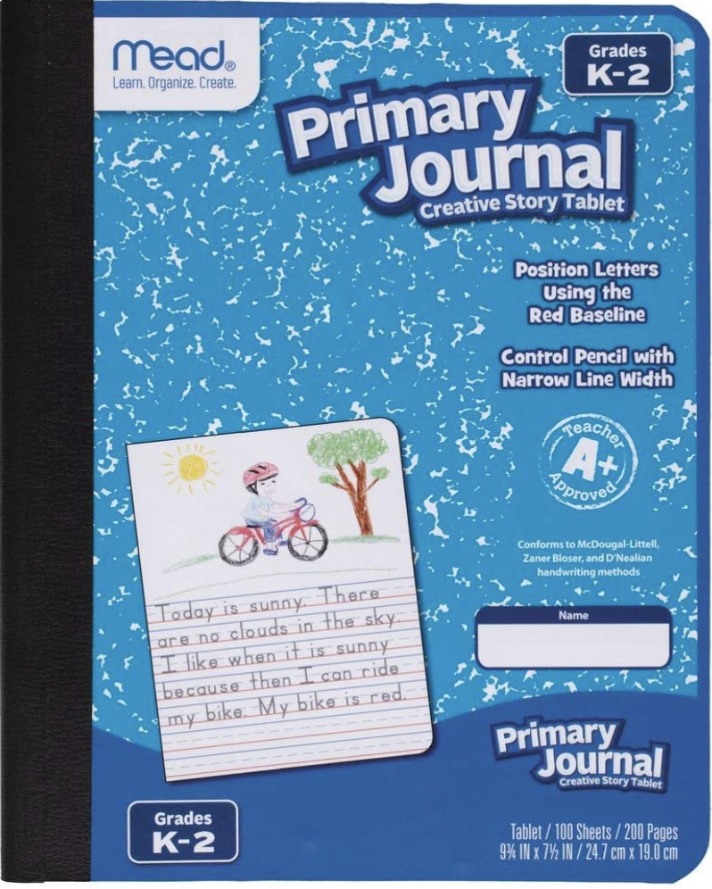**1 spiral-bound notebook (labeled with child’s name)**
* **1 Primary Journal (can be found at Walmart, half page primary ruled and half blank) (labeled) SEE PICTURES\*\*\***
* **one 1-inch WHITE three ring binder with clear insert pocket (no decorative ones, please, labeled)**
* **one 3-hole, clear, pencil pouch (labeled)**
* **one 2-pocket plastic (heavy duty) 3 prong folder (plain colors, no designs) (labeled)**
* **4 BLACK chisel-tip dry-erase markers (please NO Dixon brand)**
* 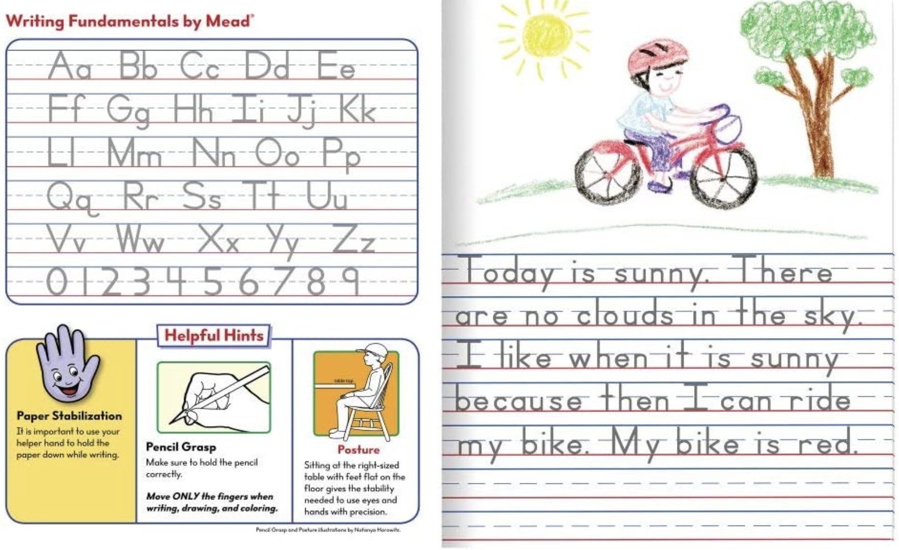**1 packages of pencil top erasers**
* **2 highlighters**
* **1 container of Clorox wipes**
* **1 bottle of hand sanitzer**
* **Headphones- no ear buds!**

**Optional**

**Paper towels**

**Additional Clorox wipes**

**Sticky notes**

**Ziplock bags (snack, sandwich, quart, or gallon)**

**Crayola washable markers**